**STUDY OF PUNE TRANSPORT SYSTEM**

The city of Pune is the second largest district in the state of Maharashtra and covers 5.10% of the total geographical area of the state. The roads and rail networks connect the district with the state capital and surrounding district headquarters. The road network of the city comprises of Express Highways, National Highways, State Highways, Major District Roads and village roads. The total length of roads in the district is 13,642 km of roads(2001) of which 39.54% roads have Bituminous surface, 26.05% roads are of water bound macadam surface and 34.41% roads are other surface roads i.e. un metalled road. Of the total road length in the district, National Highways covers 331km road length; State Highways cover 1368 km road length. Almost all the villages are well connected by water bound macadam road. Transport policies such as road widening, construction of flyovers, etc. have already been implemented in the city. But the traffic congestions still exist as the policies do not meet the increasing traffic demand. The traditional solution of “building more roads and constructing more road infrastructure to accommodate the increasing number of vehicles” will not be able to meet the traffic demand management of the city. In order to improve the traffic demand management and traffic planning of the city, it is necessary to guide the increasing traffic demand along with the road widening and road infrastructure development. This can lead to a better, comfortable, reliable, economic as well as environment friendly solution to the existing problem.

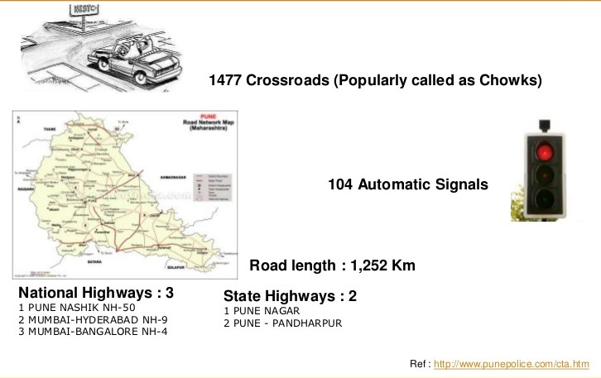

**Fig: Roadmap of pune and Accident rate at Mumbai-Pune Expressway**

***Two understand the traffic problem in PUNE. We have studied the data of two major areas of pune. There are two important interconnection in pune, one is Katraj interconnection and other one is Nalstop interconnection.***

From the variation in traffic and the traffic characteristics observed at the **Katraj intersection**, it is found thatthe major traffic volume moves from Pune to Katraj; Pune to Mumbai Pune Expressway bypass; Mumbai Pune Expressway bypass to Kondhwabudruk; and from Katraj to Pune.

From the survey done at Katraj intersection, following observations were noted about vehicle flow characteristics:

(a) For the traffic coming from Mumbai Bangalore Expressway Bypass, 75.9% traffic moves toward Kondhwa Budruk and 24.1% traffic moves towards Katraj.

(b) For the traffic coming from Katraj, 19.3% traffic moves towards Mumbai Bangalore Expressway Bypass; 75.5% traffic moves towards Pune and remaining 5.2% traffic moves towards Kondhwa Budruk.

(c) For the traffic coming from Pune, 23.7% traffic moves towards Kondhwa Budruk; 45.6% traffic moves towards Katraj; and remaining 30.7% traffic moves toward Mumbai Bangalore Expressway Bypass.

At the **Nalstop intersection**, the major traffic flow occurs from Kothrud to Deccan; Deccan to Kothrud; Kothrud to Mhatre bridge; and from mhatre bridge to Deccan.

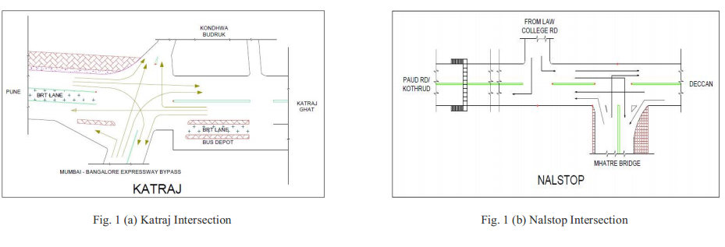

**Fig: Traffic flow at Katraj and Nalstop interconnection**

From the survey done at the two intersections, following are the reasons for the traffic congestions observed at the two intersections:

(a) The road capacity at the two intersections do not fulfil the increasing number of vehicles and the increasing traffic demand.

(b) The traffic is improperly organised causing haphazard movement of traffic in all the directions.

(c) People do not follow the traffic rules and regulations, leading to congestions at the two intersections.

(d) Lane discipline is not followed by people that hampers the smooth flow of traffic at the intersection.

(e) Adding to the congestion are the Auto rickshaw drivers that drive very rough, risking the traffic moving around.

(f) At the Katraj intersection, a large number of trucks, buses and multi axle vehicle flow which cause slow movement of vehicle in traffic thus leading to longer delays at junction creating long queues.

(g) At the Katraj intersection, the Auto rickshaws and the six seaters occupy a large space which reduces the road width by 3 meters.

(h) The Bus depot at Katraj also creates chaos at the intersection.

(i) The signal system on the Deccan Paud road is disorganised.

(j) One of the major reasons for traffic congestions at the Nalstop intersection is the frequent Breakdown of BRT which occurs generally at the rate of twice a week.

(k) The pedestrian traffic at the two intersections also create problem in smooth movement of traffic.

**CONCLUSION**

**Due to traffic jams**- **There is increasing rate of accidents, heavy pollution, wastage of manpower and weath, slowdown of econony because of poor traffic management**.

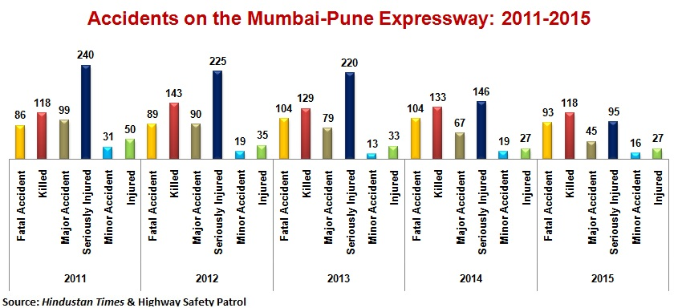

To eliminate road accidents, to save precious human life and economy of the country it is essential to find proper solution for traffic jams which is a global problem. Most importantly, proper traffic management system along with appropriate implementation of traffic rules is necessary to mitigate the problems of Traffic problems in Pune. We created the problem and we will only solve this but for that group accountability is required. This can be done if we find a solution which can include all the commuters on the road to get their contribution to remove this problem.